**Institute of Engineering & Management**

**Department of Computer Science & Engineering**

**Software Tools Laboratory for 2nd year 4th semester 2018**

**Code: CS 492**

**Date:** 4/4/2018

**WEEK-8**

**Assignment-1**

**Problem Statement:** Create multiple document interfaces with VB.

**Screen-Shot:**

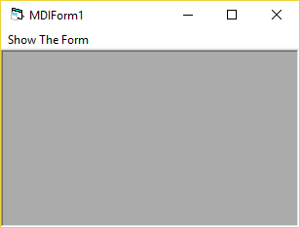 **MDIForm-1:**

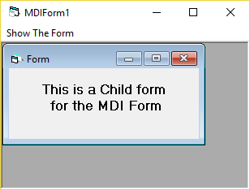Before Clicking the Menu Button

After Clicking the Menu Button

**Form Code:**

**For Form1:**

Private Sub show1_Click()

Form1.Show

End Sub

**Assignment-2**

**Problem Statement:** Create a table named “Student” in MS Access Data-Base as follows –

|  |  |  |
| --- | --- | --- |
| **Roll No.** | **Name** | **Department** |
| 1 | Rahul Bose | CSE |
| 2 | Rohit Ghosh | IT |
| 3 | Rajib Mitra | ECE |

Now write a VB6 application to fetch the record where “Department=IT” and display all the fields in a form in proper manner.

**Screen-Shot:**

**Form-1:**

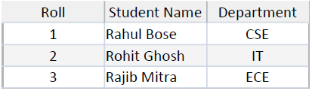‘.mdb’ Database File

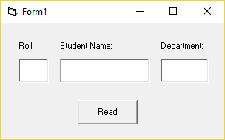

Before Clicking Read

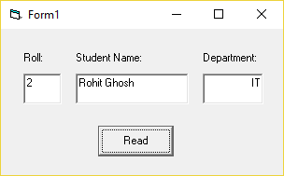

After Clicking Read

**Form Code:**

**For Form-1:**Dim conn As New ADODB.Connection  
Dim rs As New ADODB.Recordset  
Dim sqlStr As String  
  
  
Private Sub Command1_Click()  
rs.Open (sqlStr), conn, adOpenStatic, adLockReadOnly  
rs.Filter = "Department like 'IT'"  
Text1.Text = rs.Fields("Roll")  
Text2.Text = rs.Fields("Student Name")  
Text3.Text = rs.Fields("Department")  
rs.Close  
End Sub  
  
  
Private Sub Form_Load()  
sqlStr = "select * from Student"  
conn.ConnectionString = "Provider=Microsoft.Jet.OLEDB.4.0.;Data Source=C:\Database.mdb; Persist Security Info=False"  
conn.Open  
End Sub